Is Stone Bath Mat Good?

Bathrooms are the most personal space we have in our homes. A place to kickstart the day with fresh feelings and to end the day stress-free with a relaxing shower, the bathroom is my place that offers more privacy than the bedroom. I have been a long-time admirer of modern bathroom designs and amenities. And what surprised me this time with its utility is an amazing Stone Bath Mat.

In this article, I have explained all the details of this amazing bathtub mat that might help you find the answer to your question - "Is it really Good?"

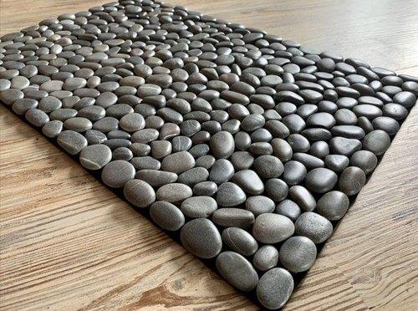

Add Extra Safety to Your Bathroom

The Songziming Non-Slip Pebble Bathtub Mat is a great bathtub mat covered with small suction pads that allow it to stick firmly to the bathtub. It allows safe movements while using the shower and thus plays a great role in adding more safety to the bathroom for your family.

For me, it is a truly necessary thing for every bathroom that I have recently added to mine.

To tell you honestly, the bathtub used to be a haunting place for me before I started using bath mats. I was afraid that someday I might slip inside the tub taking a shower and I'd be seriously injured. I guess you can sense the degree of my fear.

Though it's not the first time I am using a bathtub mat, something extra special about this Stone Bath Mat made me sit down and write this article.

Avoid Slippage - Stand Firm in the Shower

It is a slip-resistant bathtub mat that I chose for its multiple benefits. Let us discuss some of its key features first.

Features -

- Strong Adhesives

It has 200 suction cups that allow it to stick firmly to the tub's surface and prevent it from sliding towards the drain inside the tub.

The suction pads take control of the mat and work to avoid any slippery movement on smooth surfaces. Anf for me, it is the best feature of this fantastic stone mat.

- Custom Design

It comes in a standard size of 16" X 35", but I cut it out according to the size of my bathtub. It is another exciting feature of the mat that you can cut in any shape according to your requirements. But you also need to be very careful as I almost ended up cutting the wrong shape when I ordered it.

- Improved Drainage Design

The mat I was using earlier required me to rinse it often as it didn't have a proper drainage feature. The Stone Mat has spaces between the faux rocks, and you can also cut a bigger hole for drainage if required. Interesting, right?

- So Easy to Clean

It doesn't require a machine wash. You need to wash it with some towels and then place it in the shower or tub.

How Simple it is to Use

It's as easy to use the firm Bath Mat as reading this article.

- Keep the bathtub clean and free from any dirt, smudges, or oils to prevent yourself from falling.
- Make sure that the suction pads are fixed in an immovable manner before every use.
- Rinse directly with water to keep it clean and hang to dry.

Are you still wondering if it is good?

Don't worry; I'll help you decide by mentioning a few more exciting things about it, which are as follows -

- It's a non-slip mat suitable for adults and kids both.
- Smooth surface with high slip resistance makes it both comfortable and safe to use.
- Easily Washable with hands
- Beautiful design
- Easy to cut in any shape

Does it Make a Great Buy?

In one line, all I can say is that the BathTub Mat can be a fabulous addition to your bathroom to raise the levels of comfort and safety.

For me, it was worth buying it because of its significant utility in the bathrooms.

